Nepal College of Information Technology
Unit Test
Spring 2012
Program : BE ELX Time : 2 hrs
Semester : (VI) FM : 70
Subject : Filter Design PM : 35

- Candidates are requested to give their answer as far as practicable in their own words.
- The figure in the margin indicates the full marks
- Assume suitable data if necessary
- Attempt ALL question

1 a) What is filter? Illustrate different types of filters according to their frequency response in terms of gain and attenuation. [ 2+5]
b) Design a first order passive high pass filter such that its dc gain T(0)=0.3 and the gain at high frequencies is equal to T(∞)=1. The filter must have zero on the negative real axis at f_{Z} = -159 Hz. Plot the magnitude and phase of the filter. [8]

2 a) Define half power point, passband, transition band, stopband, α_{min,}, α_{max}, roll-off with necessary diagram. [7]

b) For the given filter circuit,

i) Find the transfer function
ii) Plot pole-zero locations
iii) Plot magnitude response
iv) Identify the type of filter
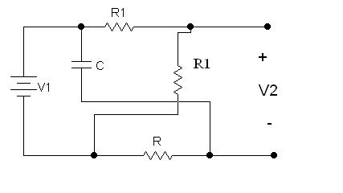[ 4+1+2+1]
Or
Why we use analog filter? According to design table, the normalized components of a passive LC filter are L₁=1.2547 H, L₂=0.9873 H, L₃=0.8765 H, C₁=2.5632 F, C₂=1.5764 F and R_{S} = R_{L} = 1 Ω. The impedance level is normalized by R_{O}= 300Ω and the normalizing frequency is f_{O} =10.8 MHz. Find the values of the denormalized components. [2+6]

3 a) Prove that the locus of poles of Chebyshev function is elliptic. Write a difference between Chebyshev approximation method and Inverse Chebyshev approximation method. [7+1]
b) Find a Chebyshev transfer function to meet following specifications.
α_{max=} 0.5 dB α_{min}=20 dB
w_{p}=1000 rad/s w_{s}= 2000 rad/s
The passband gain is 0 dB. [7]

4 a) Explain phase delay and group delay with suitable expressions. Derive the Bessel-Thomson transfer function and corresponding delay function for n=2. [4+4]
b) Determine the order and half-power frequency of the Butterworth and Chebyshev response to meet the following specifications.
w_{S=} 2.33 rad/s , w_{p}=1 rad/s, α_{max}=0.5 dB, α_{min}=22 dB [7]

5) Write short notes on (any two) [5+5]
a) Insertion gain and insertion loss
b) Design steps in Filter Design
c) Properties of Butterworth Response
d) Delay Equalization

